

LAB-7

By-Arun Lal



Sec-E

BSCS(II)

CMS-ID=023-24-0120

Exercise of Lab: 7

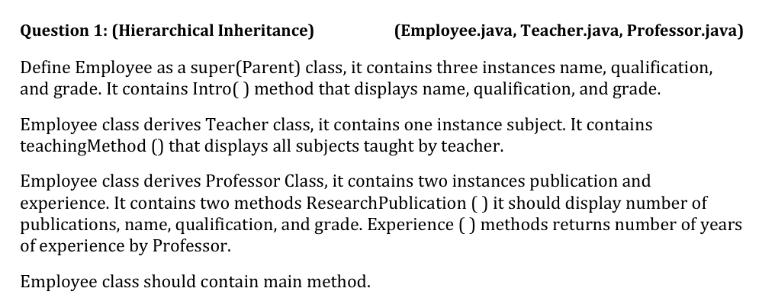

Code

class Employee {

String name, qualification, grade;

Employee(String name, String qualification, String grade) {

this.name = name;

this.qualification = qualification;

this.grade = grade;

}

void Intro() {

System.out.println("Name: " + name + ", Qualification: " + qualification + ", Grade: " + grade);

}

public static void main(String[] args) {

Teacher teacher = new Teacher("Alice", "M.Ed", "B", "Mathematics");

teacher.Intro();

teacher.teachingMethod();

Professor professor = new Professor("Dr. John", "PhD", "A", 15, 10);

professor.ResearchPublication();

System.out.println("Experience: " + professor.Experience() + " years");

}}

class Teacher extends Employee {

String subject;

Teacher(String name, String qualification, String grade, String subject) {

super(name, qualification, grade);

this.subject = subject;

}

void teachingMethod() {

System.out.println("Teaches: " + subject);

}}

class Professor extends Employee {

int publication;

int experience;

Professor(String name, String qualification, String grade, int publication, int experience) {

super(name, qualification, grade);

this.publication = publication;

this.experience = experience;

}

void ResearchPublication() {

System.out.println("Publications: " + publication + ", Name: " + name + ", Qualification: " + qualification + ", Grade: " + grade);

}

int Experience() {

return experience;

}

}

Output

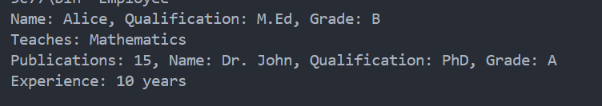

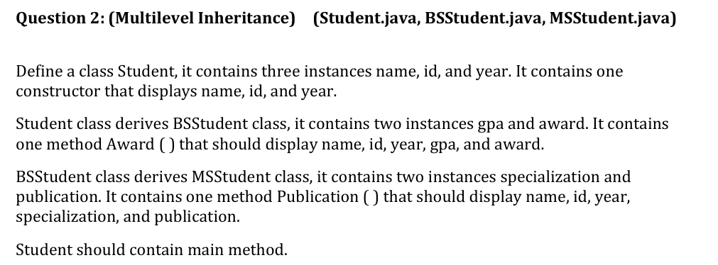

Code

class Student {

String name;

String id;

int year;

Student(String name, String id, int year) {

this.name = name;

this.id = id;

this.year = year;

System.out.println("Student: " + name + ", ID: " + id + ", Year: " + year);

}

public static void main(String[] args) {

MSStudent ms = new MSStudent("Zara", "MS123", 2023, 3.9, "Gold Medal", "AI", 2);

ms.Award();

ms.Publication();

}

}

class BSStudent extends Student {

double gpa;

String award;

BSStudent(String name, String id, int year, double gpa, String award) {

super(name, id, year);

this.gpa = gpa;

this.award = award;

}

void Award() {

System.out.println("Name: " + name + ", ID: " + id + ", Year: " + year + ", GPA: " + gpa + ", Award: " + award);

}

}

class MSStudent extends BSStudent {

String specialization;

int publication;

MSStudent(String name, String id, int year, double gpa, String award, String specialization, int publication) {

super(name, id, year, gpa, award);

this.specialization = specialization;

this.publication = publication;

}

void Publication() {

System.out.println("Name: " + name + ", ID: " + id + ", Year: " + year + ", Specialization: " + specialization + ", Publications: " + publication);

}

}

Output

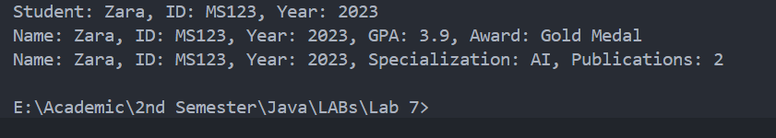

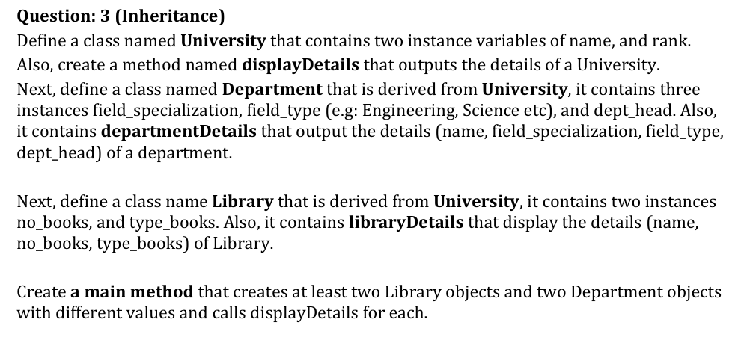

Code

class University {

String name;

int rank;

University(String name, int rank) {

this.name = name;

this.rank = rank;

}

void displayDetails() {

System.out.println("University Name: " + name + ", Rank: " + rank);

}

public static void main(String[] args) {

Department d1 = new Department("IBA Sukkur", 2, "Computer Science", "Engineering", "Dr. Ahmed");

Department d2 = new Department("IBA Sukkur", 2, "Physics", "Science", "Dr. Raza");

Library l1 = new Library("IBA Sukkur", 2, 5000, "Technical");

Library l2 = new Library("IBA Sukkur", 2, 3000, "Fiction");

d1.displayDetails();

d1.departmentDetails();

d2.departmentDetails();

l1.displayDetails();

l1.libraryDetails();

l2.libraryDetails();

}

}

class Department extends University {

String field_specialization, field_type, dept_head;

Department(String name, int rank, String specialization, String type, String head) {

super(name, rank);

this.field_specialization = specialization;

this.field_type = type;

this.dept_head = head;

}

void departmentDetails() {

System.out.println("Department: " + field_specialization + ", Type: " + field_type + ", Head: " + dept_head);

}

}

class Library extends University {

int no_books;

String type_books;

Library(String name, int rank, int no_books, String type_books) {

super(name, rank);

this.no_books = no_books;

this.type_books = type_books;

}

void libraryDetails() {

System.out.println("Library Books: " + no_books + ", Type: " + type_books);

}

}

Output

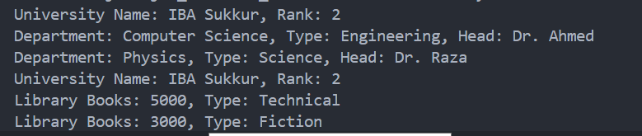

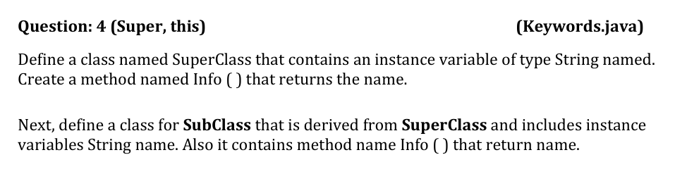

Code

class SuperClass {

String name;

SuperClass(String name) {

this.name = name;

}

String Info() {

return name;

}

}

class SubClass extends SuperClass {

String name;

SubClass(String superName, String subName) {

super(superName);

this.name = subName;

}

String Info() {

return name;

Output



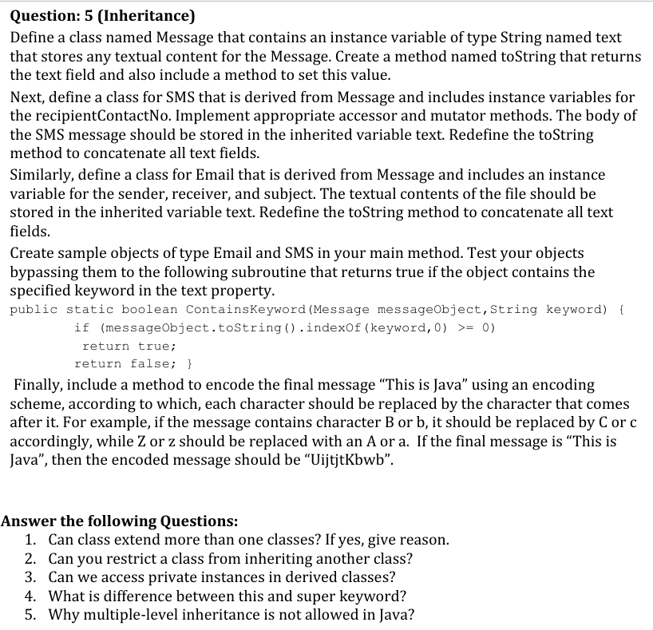

Code

class Message {

String text;

void setText(String text) {

this.text = text;

}

public String toString() {

return text;

}

}

class SMS extends Message {

String recipientContactNo;

void setRecipient(String contact) {

this.recipientContactNo = contact;

}

public String toString() {

return "To: " + recipientContactNo + ", Message: " + text;

}

}

class Email extends Message {

String sender, receiver, subject;

void setEmailDetails(String sender, String receiver, String subject) {

this.sender = sender;

this.receiver = receiver;

this.subject = subject;

}

public String toString() {

return "From: " + sender + ", To: " + receiver + ", Subject: " + subject + ", Message: " + text;

}

}

public class Keywords {

public static boolean ContainsKeyword(Message messageObject, String keyword) {

return messageObject.toString().contains(keyword);

}

public static String encodeMessage(String msg) {

StringBuilder encoded = new StringBuilder();

for (char ch : msg.toCharArray()) {

if (Character.isLetter(ch)) {

char base = Character.isLowerCase(ch) ? 'a' : 'A';

encoded.append((char)((ch - base + 1) % 26 + base));

} else {

encoded.append(ch);

}

}

return encoded.toString();

}

public static void main(String[] args) {

SMS sms = new SMS();

sms.setText("Meeting at 3PM");

sms.setRecipient("1234567890");

Email email = new Email();

email.setText("Java project deadline extended");

email.setEmailDetails("teacher@iba.edu", "student@iba.edu", "Project Update");

System.out.println(sms);

System.out.println(email);

System.out.println("Contains 'Java'? " + ContainsKeyword(email, "Java"));

String message = "This is Java";

System.out.println("Encoded Message: " + encodeMessage(message));

}

}

Output

